INSTALL FOLDERS TO LINUX

sudo apt install tree

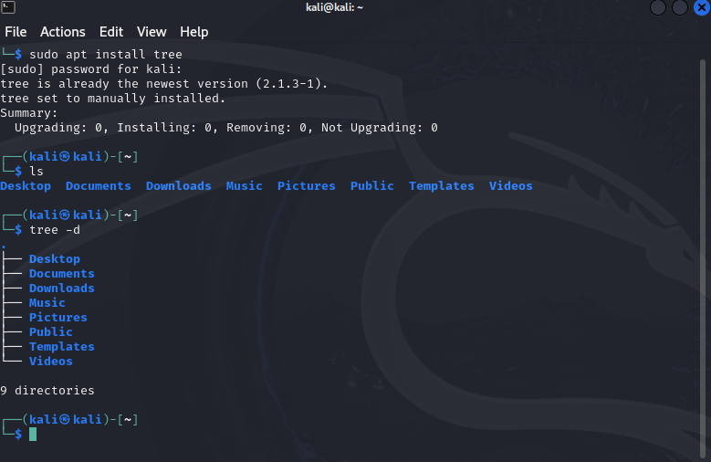

This One Command Instantly Organizes Your Linux Folders



🌳 Tree Command in Linux: Organize & Visualize Folders Instantly
The tree command is a powerful Linux utility that lets you display directories and their contents in a tree-like format. This is extremely helpful for organizing, understanding, or documenting file structures—especially when dealing with nested directories.

🔧 Step 1: Install tree
If tree is not already installed, use the following command:

bash
CopyEdit
sudo apt install tree
✅ This command uses apt, the package manager for Debian-based systems (like Ubuntu, Kali Linux, etc.).
Your output might look like this if it’s already installed:

bash
CopyEdit
tree is already the newest version (2.1.3-1).

📁 Step 2: Display Only Directories
To view only the folder structure (excluding files), use:

bash
CopyEdit
tree -d
Example Output:

bash
CopyEdit
.
├── Desktop
├── Documents
├── Downloads
├── Music
├── Pictures
├── Public
├── Templates
├── Videos
9 directories
This gives you a clean view of your directory hierarchy.

🧰 Step 3: Limit the Output for Large Structures
If you're in a directory with tons of files or folders, it can get overwhelming. Use the --filelimit option to limit how many files per directory tree displays.

bash
CopyEdit
tree --filelimit 15
This limits the number of files shown in each directory to 15. Beyond that, you'll see:

css
CopyEdit
[...]
[67 entries exceeds filelimit, not opening dir]
This is great for performance and readability in large projects or system directories.

🪄 Step 4: Add More Info (Hidden Files & File Sizes)
To get a more informative display, including:
- Hidden files (those starting with .)
- Human-readable file sizes (e.g., KB, MB)
Use:

bash
CopyEdit
tree --filelimit 15 -ah
- -a: Includes hidden files.
- -h: Displays file sizes in a human-readable format (e.g., 1.2K, 5.5M).
Example:

css
CopyEdit
.
├── .bashrc [2.2K]
├── .config/
│ └── settings.json [1.1K]
├── Documents/
│ ├── notes.txt [5.6K]
│ └── project.docx [48.7K]

🎯 Bonus: Save Output to a File
Want to document your folder structure or share it?

bash
CopyEdit
tree --filelimit 15 -ah > folder-structure.txt
Then open the file with any text editor or share it as part of documentation.

💡 Use Cases
- 📚 Creating technical documentation.
- 🧪 Debugging complex project structures.
- 🗂️ Organizing user files in a home directory.
- 🛡️ Cybersecurity analysis of suspicious folder growth (great for SOC analysts!).

📸 Screenshot Reference
Your screenshot shows:
- Installation of tree
- Use of ls to list folders
- Use of tree -d to display directories under the home folder
This is a perfect starting point for beginners getting familiar with the Linux file system.

✅ Summary of Common tree Flags
Flag | Description
-d | Show directories only
-a | Include hidden files
-h | Human-readable file sizes
--filelimit N | Limit files per directory shown to N
-L N | Limit display to N levels of depth
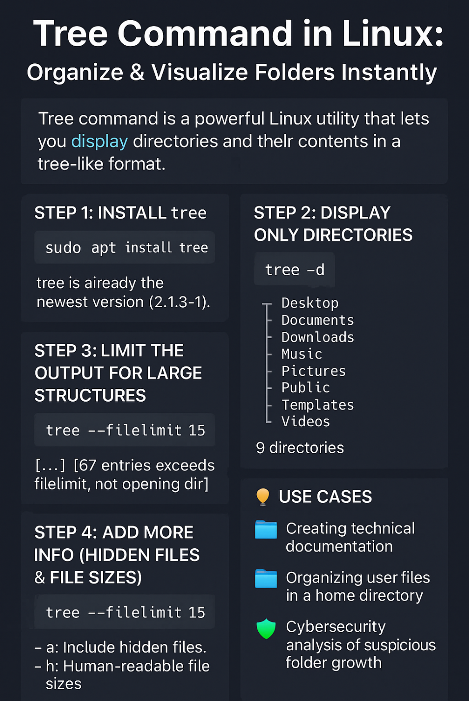
<<Linux_Tree_Command_Tutorial.pdf>>

